Problem Statement: Stepwise Execution Analysis of Sorting Algorithms I
Bubble Sort
Theory:
- Initialize an integer array with user input
- Sort the array using Bubble Sort:
- Initialize two counters: cntSwap (to count swaps) and cntCompare (to count comparisons).
- For each pass from the first element to the second last element:
- Set a boolean flag swapped to false.
- For each element from the start up to the last unsorted element (which decreases with each
pass):
- Compare the current element with the next element.
- Increment the comparison counter cntCompare.
- If the current element is greater than the next element:
Swap the two elements.
Set swapped to true.
- Increment the swap counter cntSwap.
- If no swaps occurred during this pass (swapped is false), the array is sorted; break out of
the loop early.
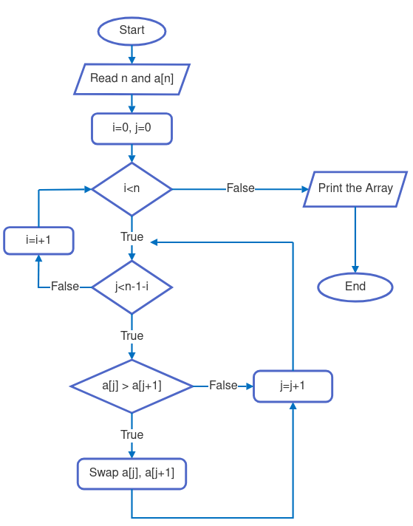
- Print the total number of swaps and comparisons performed during the sorting process.

Code:
- #include <iostream>
- #include <ctime>
- using namespace std;

- void printArray(int *array, int size) {
- cout << "Array Elements are : ";
- for (int i = 0; i < size; i++) {
- cout << array[i] << " ";
- }
- cout << endl;
- }
- void gentArray(int *array, int n, string type) {
- srand(time(NULL));
- for (int i = 0; i < n; i++)
- array[i] = rand() % 850 + 7;
- if (type == "average")
- return;
- for (int i = 0; i < n - 1; i++)
- for (int j = 0; j < n - 1 - i; j++)
- if (array[j] > array[j + 1]) {
- swap(array[j], array[j + 1]);
- }
- if (type == "worst")
- for (int i = 0; i < n / 2; i++) {
- swap(array[i], array[n - 1 - i]);
- }
- }
- void bubbleSort(int *array, int n) {
- int cntSwap = 0;
- int cntCompare = 0;
- for (int i = 0; i < n - 1; i++) {
- bool swapped = false;
- for (int j = 0; j < n - 1 - i; j++) {
- if (array[j] > array[j + 1]) {
- swap(array[j], array[j + 1]);
- swapped = true;
- cntSwap++;
- }
- cntCompare++;
- }
- if (!swapped)
- break;
- }
- cout << "Swapping : " << cntSwap << endl;;
- cout << "Comparing : " << cntCompare << endl;
- }
- int main() {
- string cases;
- cout << "Case (best, average, worst) ?: ";
- cin >> cases;
- int size;
- cout << "Element Size ? : ";
- cin >> size;

- int *array = new int[size];
- gentArray(array, size, cases);
- cout << "\nCase: " << cases << " | ";
- cout << "Size: " << size << endl;

- printArray(array, size);
- bubbleSort(array, size);
- printArray(array, size);

- delete[] array;
- return 0;
- }
Screenshots:

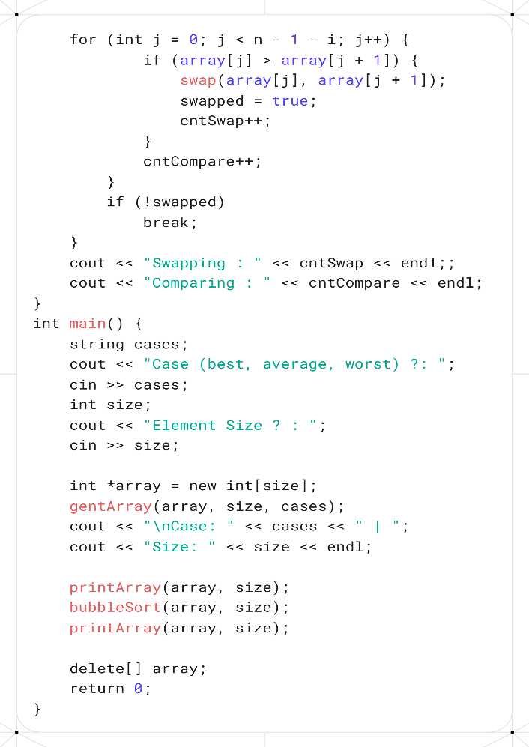
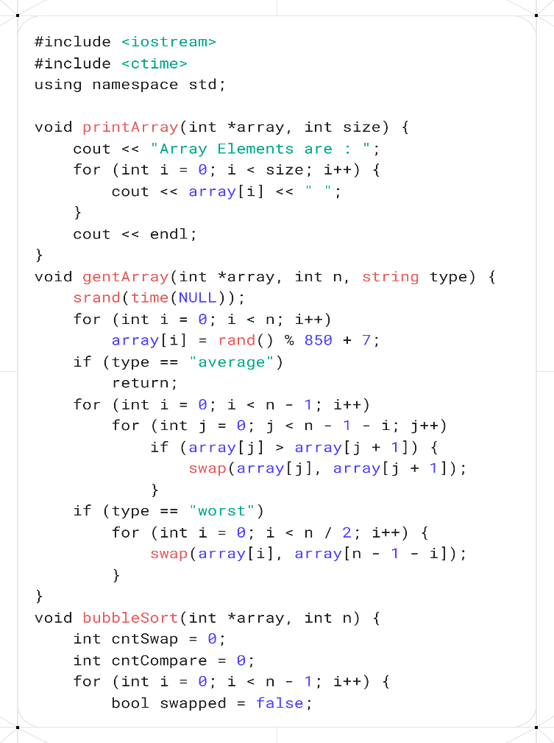

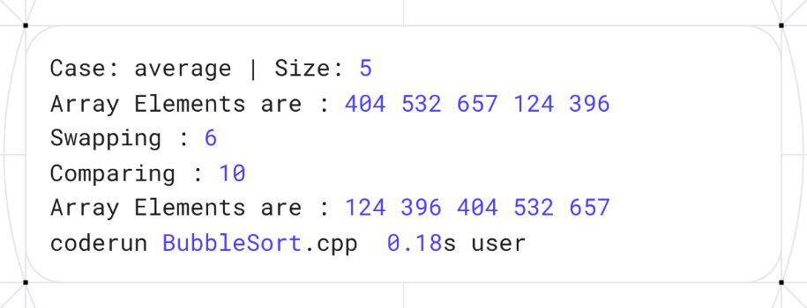

Analysis: Input Array: A = [404, 532, 657, 124, 396]
Stepwise Execution (Pass by Pass):
Pass 1 (i = 1):
Compare 404 and 532 → no swap → [404, 532, 657, 124, 396]
Compare 532 and 657 → no swap → [404, 532, 657, 124, 396]
Compare 657 and 124 → swap → [404, 532, 124, 657, 396]
Compare 657 and 396 → swap → [404, 532, 124, 396, 657]
Pass 2 (i = 2):
Compare 404 and 532 → no swap → [404, 532, 124, 396, 657]
Compare 532 and 124 → swap → [404, 124, 532, 396, 657]
Compare 532 and 396 → swap → [404, 124, 396, 532, 657]
Pass 3 (i = 3):
Compare 404 and 124 → swap → [124, 404, 396, 532, 657]
Compare 404 and 396 → swap → [124, 396, 404, 532, 657]
Pass 4 (i = 4):
Compare 124 and 396 → no swap → [124, 396, 404, 532, 657]
Final Sorted Array: [124, 396, 404, 532, 657]
Insertion Sort
Theory:
- Initialize an integer array with user input.
- Print the array elements:
  - Iterate through the array from the first to the last element.
  - Print each element followed by a space.
- Sort the array using Insertion Sort:
  - Initialize two counters: shiftingCount (to count the number of shifts) and compareCount (to count the number of comparisons).
  - For each element from the second element (index 1) to the last:
    - Store the current element as key.
    - Initialize j as the index before the current element.
    - While j is non-negative and the element at j is greater than key:
      - Shift the element at j one position to the right (to j + 1).
      - Decrement j.
      - Increment the comparison counter compareCount.
    - Insert the key at position j + 1.
    - Increment the shifting counter shiftingCount.
- Print the total number of shifts and comparisons performed during sorting.
- Print the sorted array elements:
  - Iterate through the array and print each element followed by a space.
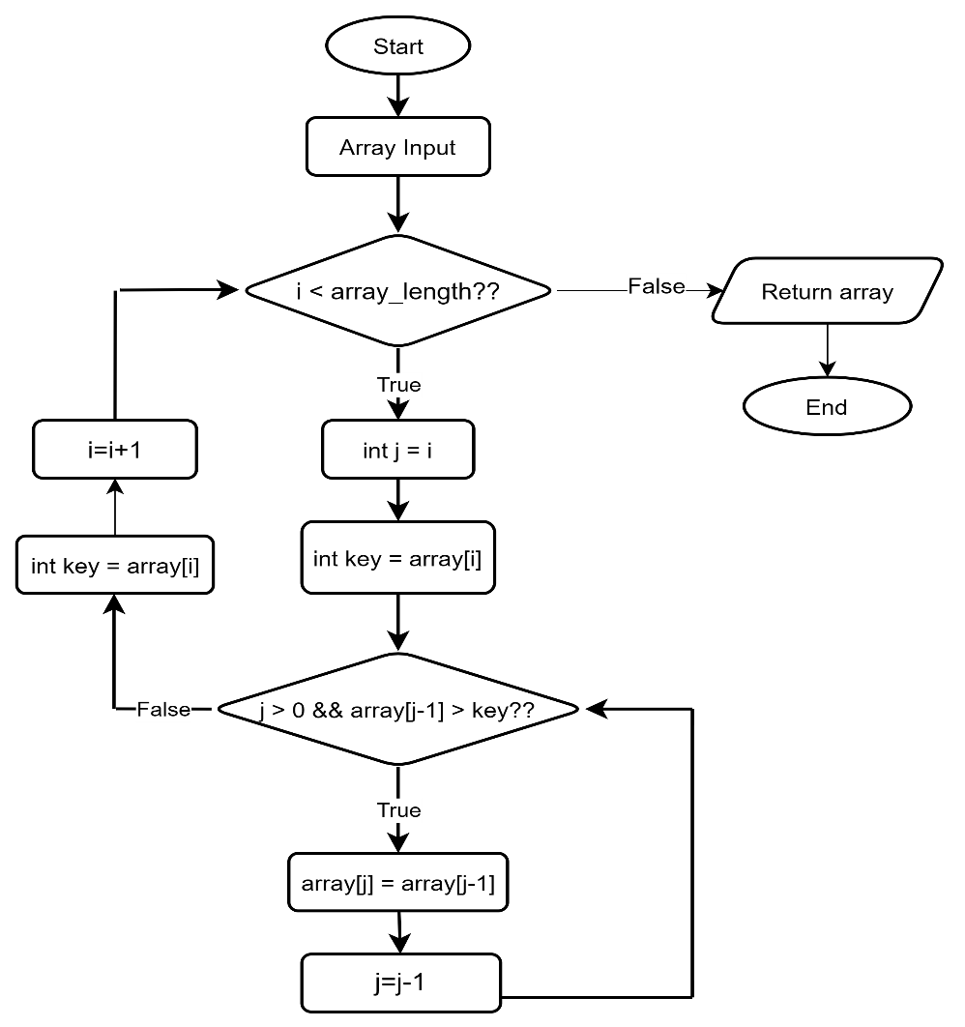

Code:
- #include <iostream>
- #include <ctime>
- using namespace std;

- void printArray(int *array, int size) {
- cout << "Array Elements are : ";
- for (int i = 0; i < size; i++) {
- cout << array[i] << " ";
- }
- cout << endl;
- }
- void gentArray(int *array, int n, string type) {
- srand(time(NULL));
- for (int i = 0; i < n; i++)
- array[i] = rand() % 600 + 132;
- if (type == "average")
- return;
- for (int i = 0; i < n - 1; i++)
- for (int j = 0; j < n - 1 - i; j++)
- if (array[j] > array[j + 1]) {
- swap(array[j], array[j + 1]);
- }
- if (type == "worst")
- for (int i = 0; i < n / 2; i++) {
- swap(array[i], array[n - 1 - i]);
- }
- }
- void insertionSort(int *array, int n) {
- int shiftingCount = 0;
- int compareCount = 0;
- for (int i = 1; i < n; i++) {
- int key = array[i];
- int j = i - 1;
- while (j >= 0 && array[j] > key) {
- array[j + 1] = array[j];
- j--;
- compareCount++;
- }
- array[j + 1] = key;
- shiftingCount++;
- }
- cout << "Shifting : " << shiftingCount << endl;
- cout << "Comparing : " << compareCount << endl;
- cout << "After sorting, ";
- printArray(array, n);
- }

- int main() {
- string cases;
- cout << "Case (best, average, worst) ?: ";
- cin >> cases;
- int size;
- cout << "Element Size ? : ";
- cin >> size;

- int *array = new int[size];
- gentArray(array, size, cases);
- cout << "\nCase: " << cases << " | ";
- cout << "Size: " << size << endl;

- printArray(array, size);
- insertionSort(array, size);
- delete[] array;
- return 0;
- }
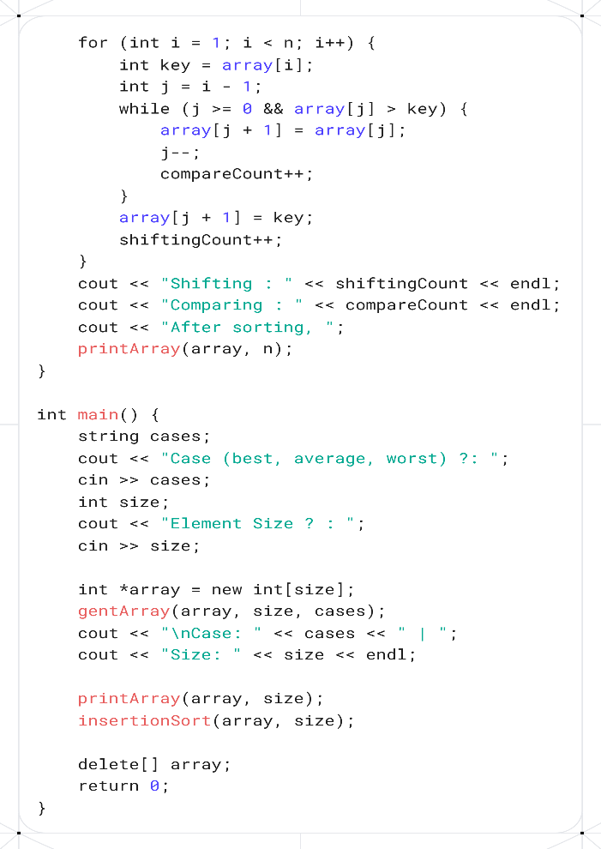
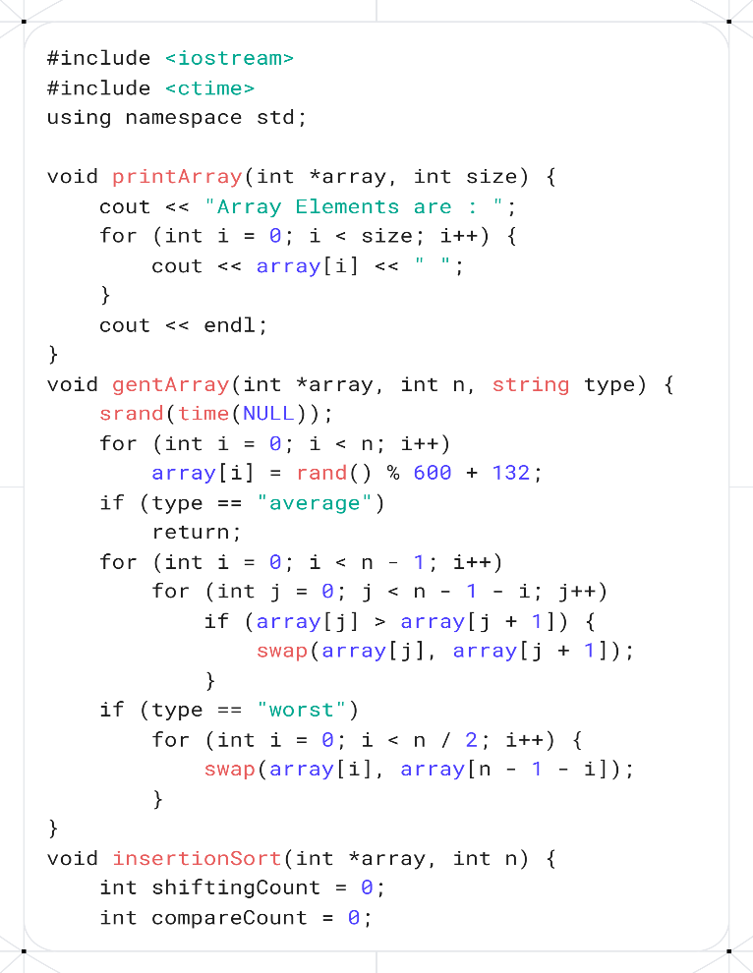
Screenshots:

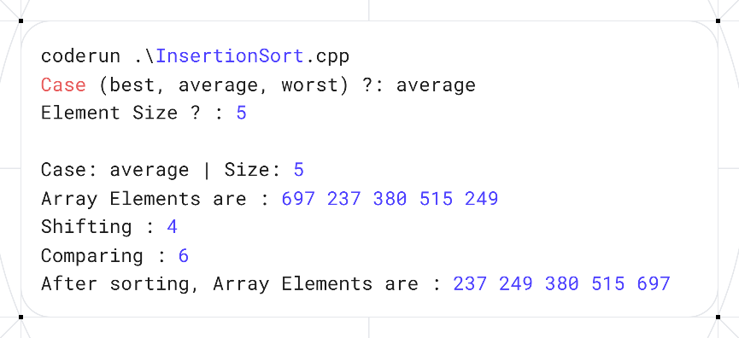

Analysis: Input Array: A = [697, 237, 380, 515, 249]

Stepwise Execution (Pass by Pass):
Pass 1 (i = 1):
Key = 237
Compare 697 and 237 → 697 > 237 → shift 697 right → [697, 697, 380, 515, 249]
Insert 237 at position 0 → [237, 697, 380, 515, 249]
Pass 2 (i = 2):
Key = 380
Compare 697 and 380 → 697 > 380 → shift 697 right → [237, 697, 697, 515, 249]
Compare 237 and 380 → 237 < 380 → stop shifting
Insert 380 at position 1 → [237, 380, 697, 515, 249]
Pass 3 (i = 3):
Key = 515
Compare 697 and 515 → 697 > 515 → shift 697 right → [237, 380, 697, 697, 249]
Compare 380 and 515 → 380 < 515 → stop shifting
Insert 515 at position 2 → [237, 380, 515, 697, 249]
Pass 4 (i = 4):
Key = 249
Compare 697 and 249 → 697 > 249 → shift 697 right → [237, 380, 515, 697, 697]
Compare 515 and 249 → 515 > 249 → shift 515 right → [237, 380, 515, 515, 697]
Compare 380 and 249 → 380 > 249 → shift 380 right → [237, 380, 380, 515, 697]
Compare 237 and 249 → 237 < 249 → stop shifting
Insert 249 at position 1 → [237, 249, 380, 515, 697]

Final Sorted Array: [237, 249, 380, 515, 697]

Selection Sort

Theory:.
Code:
Screenshots:


Analysis:

Observation Table
Test Case No. | Input Size (n) | Number of Comparison |  | Number of Swap/Shift |  | Execution Time
 |  | Bubble Sort | Selection Sort | Bubble Sort | Selection Sort | Bubble Sort | Selection Sort
01 | 10 (Best)
02 | 10 (Average)
03 | 10 (Worst)
04 | 100 (Best)
05 | 100 (Average)
06 | 100 (Worst)
07 | 1000 (Best)
08 | 1000 (Average)
09 | 1000 (Worst)

Conclusion: Write a brief conclusion stating for what kind of data and when it is suitable to use selection/bubble/insertion sort algorithms.

